CYBERQUOTE PTE LTD

Sales Performance Management
Phase III

Program Design Specification
- Assignment History

For: | CYBERQUOTE PTE LTD | Project Ref: | PM1001
Author: | Thet Su Mon | Doc Ref: | SpmPhaseIII-TS-PS-AssignmentHistory -1.0
Proj Mgr: | Ei Ei Thu | Version:
Date: | 19/10/2011 | Classification:
To : |  | Cc:

Document Revision History

Document Title :

Version | Revised by | Effective Date | Summary of Change | Reason for change
1.0 | Thet Su | 19/10/2011 | New Document | -

Table of Contents

1 Program Definition 3
1.1 System Name 3
1.2 Program Description 3
1.3 Programming Language/Version 3
1.4 Drivers Required/Version 3
2 Structure Design 3
2.1 Block Chart or Flow Chart on top level structure of the program 3
2.1.1 Presentation Layer 3
2.1.2 Web Service Layer 4
2.2 Description of each module 5
2.2.1 Presentation Layer 5
2.2.2 WebService Layer 6
2.3 Description of Stored Procedures used 7
3 Input/Output files used 7
3.1 Input/Output file format design (with Samples attached) 7
3.2 Database connections used 7
4 Error Message/Warning Message List 7
5 Program List 7
6 Acceptance Form 8

Program Definition

System Name
Sales Performance Management (hereinafter referred as SPM) system Phase III

Program Description
This is the program design specification of “Assignment History” function which is defined under “Assignment History” in the design specification.

Programming Language/Version
This program will be developed in C# using Visual Studio 2008 for running under ASP.net 3.5.

Drivers Required/Version
The ASP.NET AJAX 1.0 is required to support Ajax in ASP.NET environment.

Structure Design

Block Chart or Flow Chart on top level structure of the program

Presentation Layer

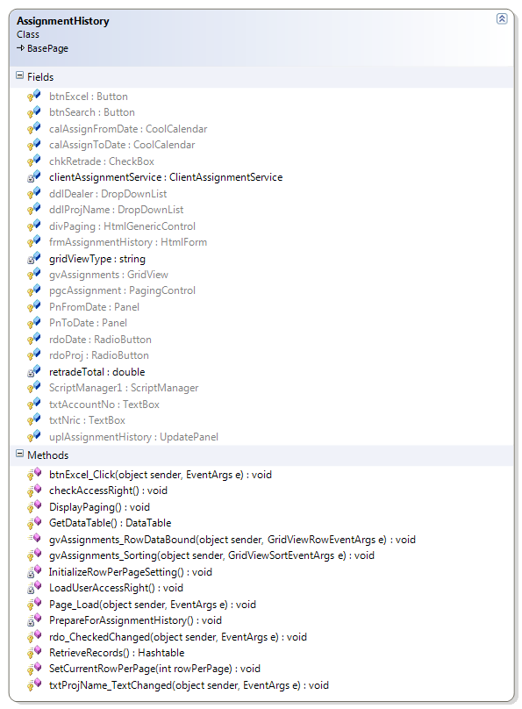

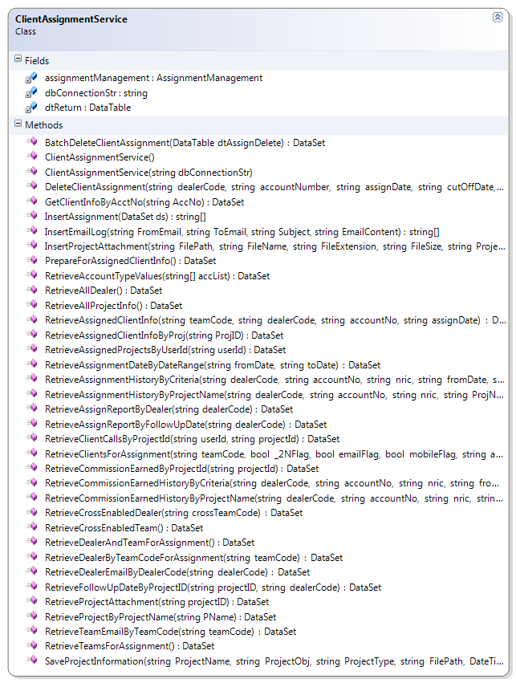

Web Service Layer

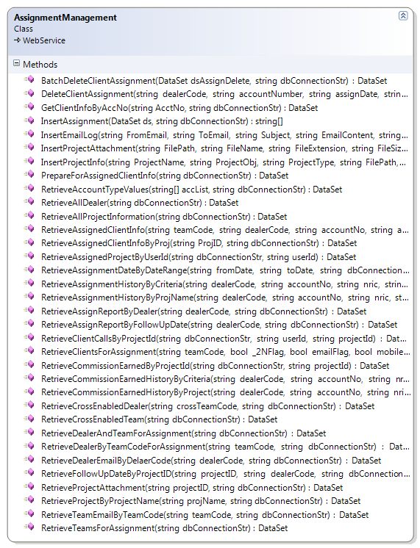
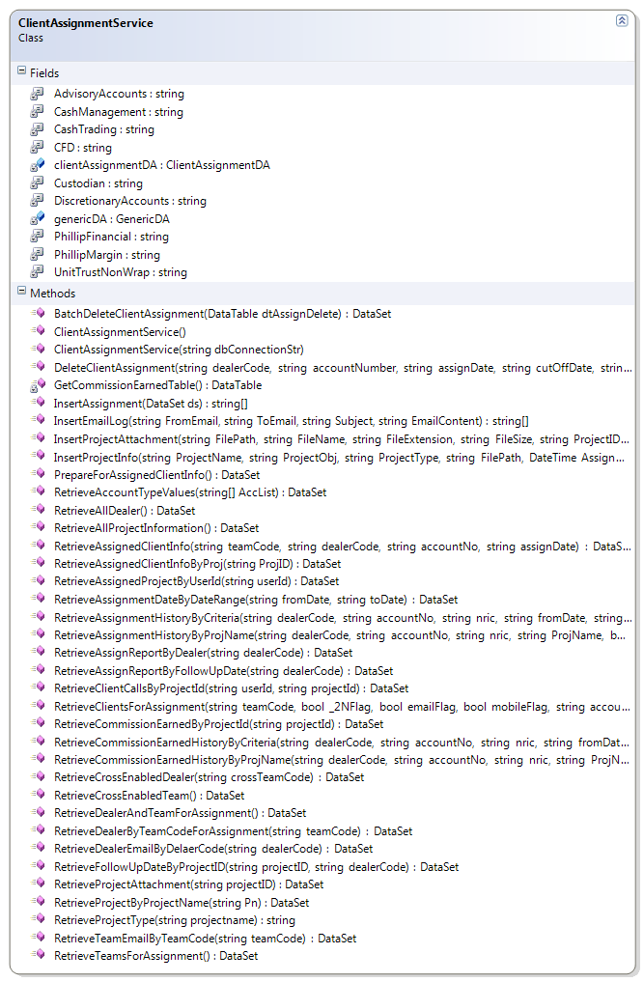
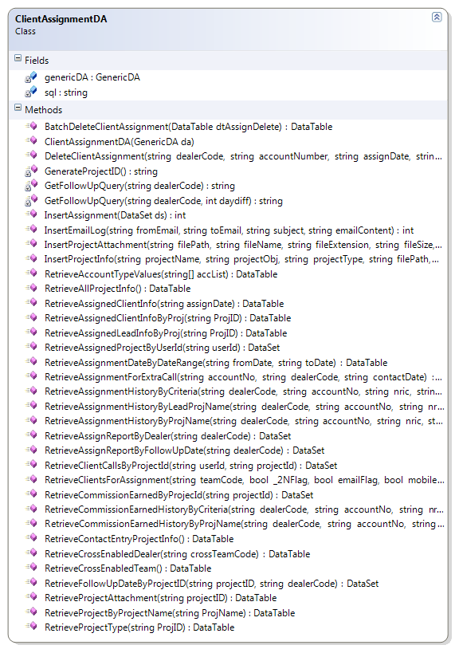

Description of each module

Presentation Layer

AssignmentHistory.aspx.cs
Member | Description
Fields
clientAssignmentService | Control for accessing web service layer
retradeTotal | Use to display total re-trade amount after assignment.
gridViewType | To use for generating excel report.
Methods
Page_Load | Retrieve and construct user dropdown list
PrepareForAssignmentHistory | Set Assign Date From value to one week from current date and Assign Date to value to current date. Retrieve and construct dealers dropdownlist.
RetrieveRecords | Retieve assignments by calling clientAssignmentServiceRetrieveAssignmentHistoryByCriteria () method;  Construct gridview to show assignment records.
InitializeRowPerPageSetting | Set default values for paging user control.
DisplayPaging | Use to display paging user control after assignment records is retrieved from database.
SetCurrentRowPerPage | Call from BasePage class to store current row per page in viewstate for paging control whenever user change the value.
GetDataTable | Call from BasePage class to get data to display whenever user change the page no (or) row per page.
checkAccessRight | Check the access right and enable or disable the button according to the access right.
LoadUserAccessRight | Retrieve the User access right.
Rdo_CheckedChanged | To enable or disable the calendar or drop down list.
txtPrijName_TextChanged | Retrieve assignment project name for users to use in search the assigned client info.
btnExcel_Click | Generate excel file for retrieved assignment records.
gvAssignments_Sorting | Perform sorting on retrieved assignment records.
gvAssignments_RowDataBound | Display miss called assignments as red color. Calculate and displays re-trade total value for retrieved assignment records.

ClientAssignmentService.cs
Member | Description
Fields
dbConnectionStr | Database connection string
assignmentManagement | Reference of the assignment management web service
dtReturn | Return Datatable
Methods
ClientAssignmentService | Constructor: to create assignment management web service instance
ClientAssignmentService (string cnStr) | Constructor: get database connection from caller after ClientAssignmentService () constructor
PrepareForAssignedClientInfo | Retrieve all the dealers to use in searching assignments.
RetrieveProjectByProjectName | Retrieve all the project names to use in searching assignments.
RetrieveAssignmentHistoryByCriteria | Retrieve all the assignments which matched with user enter criteria.
RetrieveAssignmentHistoryByProjectName | Retrieve all the assignments which matched with user enter project name criteria.

WebService Layer

AssignmentManagementService.asmx.cs
Member | Description
Methods
PrepareForAssignmentClientinfo | Retrieve all the dealers to use in searching assignments.
RetrieveProjectByProjectName | Retrieve all the project names to use in searching assignments.
RetrieveAssignmentHistoryByCriteria | Retrieve all the assignments which matched with user enter assignment date criteria.
RetrieveAssignmentHistoryByProjName | Retrieve all the assignments which matched with user enter project name criteria.

ClientAssignmentService.cs
Member | Description
Fields
clientAssignmentDA | Data access layer for client assignment services
dtReturn | Return datatable
GenericDA | Generic data access layer
returnCode | Return Code  1 – Successful  -1 – Failed
returnMessage | Return message
Methods
ClientAssignmentService | Constructor: to create generic data access and client assignment data access instance
ClientAssignmentService (string cnStr) | Constructor: get database connection from caller after ClientAssignmentService () constructor
PrepareForAssignmentHistory | Retrieve all the dealers to use in searching assignments.
RetrieveProjectByProjectName | Retrieve all the project names to use in searching assignments.
RetrieveAssignmentHistoryByCriteria | Retrieve all the assignments which matched with user enter assigned date criteria.
RetrieveAssignmentHistoryByProjName | Retrieve all the assignments which matched with user enter project name criteria.

ClientAssignmentDA.cs
Member | Description
Fields
GenericDA | Generic data access layer
sql | Sql statements
Methods
PrepareForAssignmentHistory | Retrieve all the dealers to use in searching assignments.
RetrieveProjectByProjectName | Retrieve all the project names to use in searching assignments.
RetrieveAssignmentHistoryByCriteria | Retrieve all the assignments which matched with user enter criteria.
RetrieveAssignmentHistoryByProjName | Retrieve all the assignments which matched with user enter client project name criteria.
RetrieveAssignmentHistoryByLeadProjName | Retrieve all the assignments which matched with user enter lead project name criteria.

Description of Stored Procedures used
None

Input/Output files used
None

Input/Output file format design (with Samples attached)
N/A

Database connections used
BasePage.dbConnectionStr

Error Message/Warning Message List
Message | Cause
No Assignments found! Please change your search criteria.! | No matched record is found for user entered search criteria.
Error in retrieving Assignments! Please try again. | When system failed to retrieve assignment records.
Problem in WebService Connection! | When system failed to call web service
Please retrieve Assignments/Projects first before searching Call Report. | User doesn’t select the Assignment date or project name then clicking the search button.
No records to generate Excel File! | When user click the excel button, no records to generate.

Program List
SPMWebApp\Services
ClientAssignmentService.cs

SPMWebApp\WebPages\AccessControl
AssignmentHistory.aspx
AssignmentHistory.aspx.cs
AssignmentHistory.aspx.designer.cs

SPMWebServiceApp\WebServices
AssignmentManagement.asmx
AssignmentManagement.asmx.cs

SPMWebServiceApp\Services
ClientAssignmentService.cs

SPMWebServiceApp\DataAccess
ClientAssignmentDA.cs

Acceptance Form

Project Name : | Sales Performance Management Phase II
Document Name : | Program Design Specification – Assignment History  (Doc Ref: SpmPhaseII-TS-PS-AssignmentHistory-1.0)
Company Name : | CyberQuote Pte Ltd
Project Manager : | Li Qun
Designation : | Snr Consultant
Signature/Date :

